**Azure devops project:**

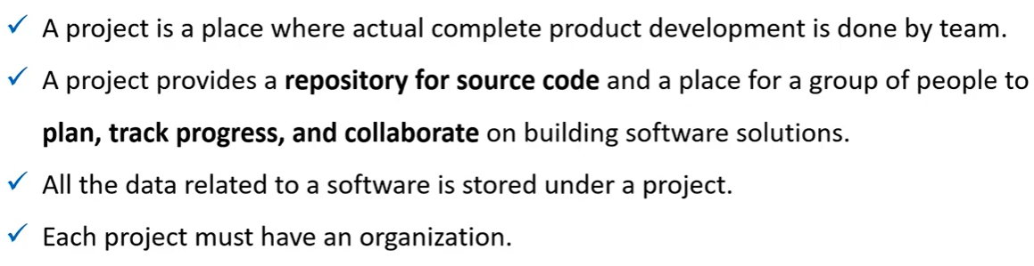

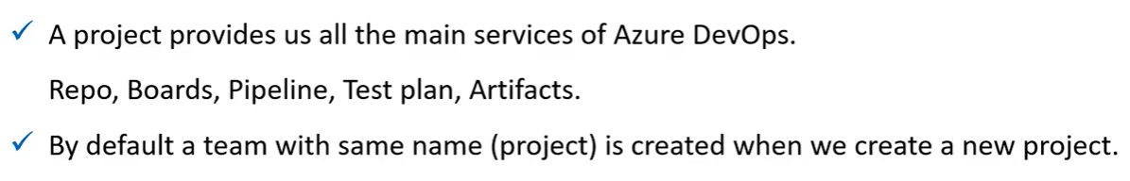

Whenever we create a project, a new team will be created with the same name.

**Types of projects:**

We have two types of projects.

* **Public project**
* **Private project**

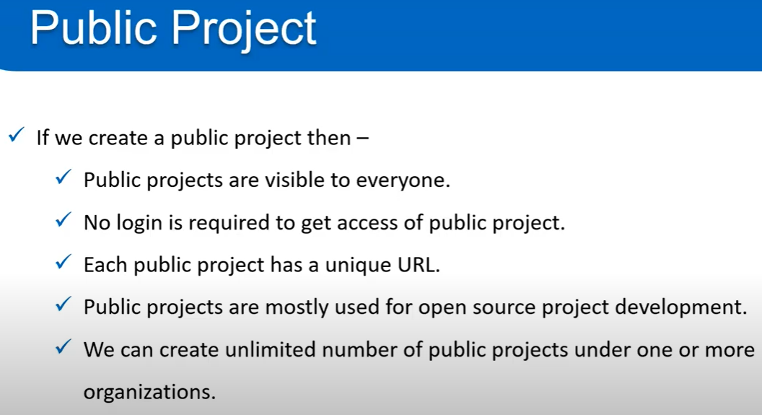

* The public project can be accessed by anyone. We just need the URL of the project to access. No need of any authentication.
* So, the public project name should be unique.

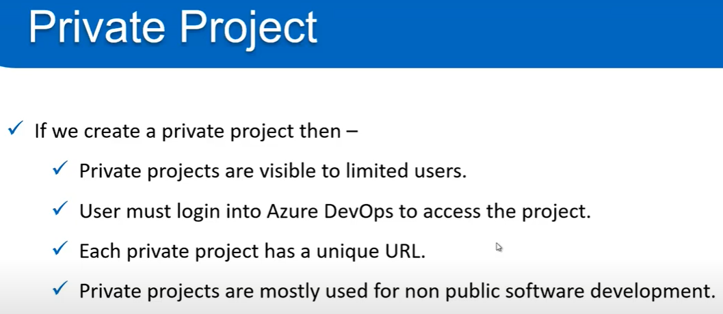

**Creating project:**

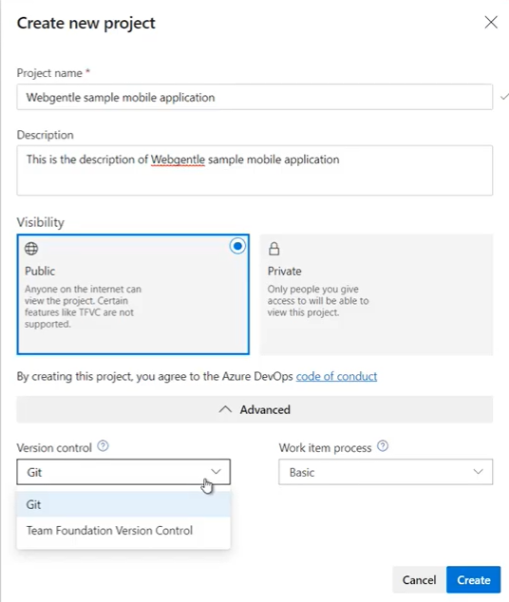

* While creating a project, we can select version control either git or TFVC as above.

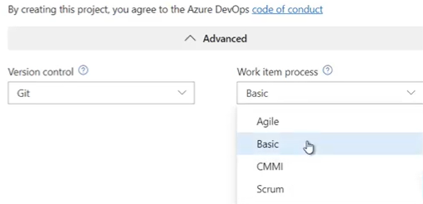

* Also, the work item process we can choose as above.
* The **“board”** of the project depends on the type of work process we choose.

**Project settings:**

**Overview:**

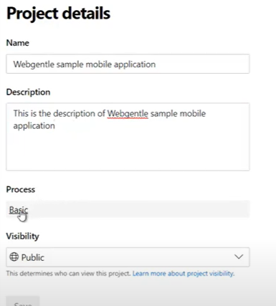

* We can change the project name, add description. Change the work process may be and visibility also as above.

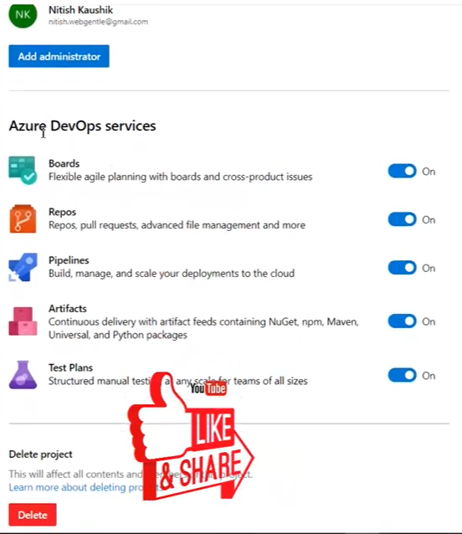

* And, we can add administrators, enable/disable services and we can also delete the project as above.

**Teams:**

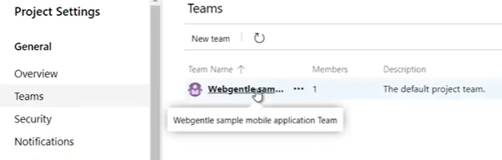

* We can see the teams above. By default, one team gets created. If we click on that. We can see the users in that team.
* We can add more than one team.

**Security:**

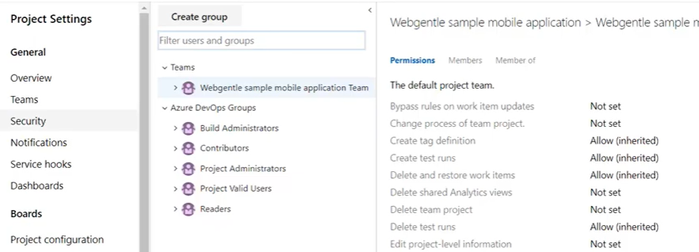

* We can maintain security related stuff here. Like giving or blocking access etc.

**Notifications:**

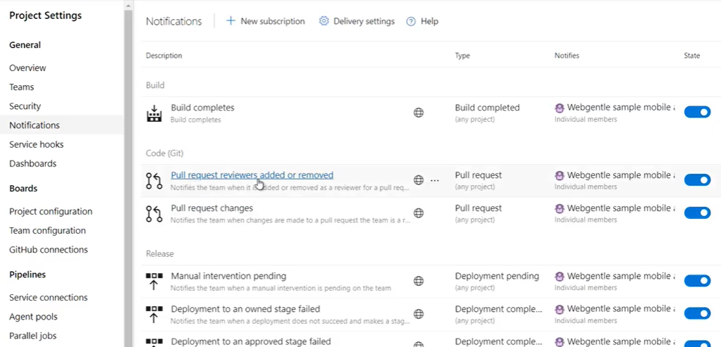

* We can manage notifications here as above.

**Setup a team for the project:**

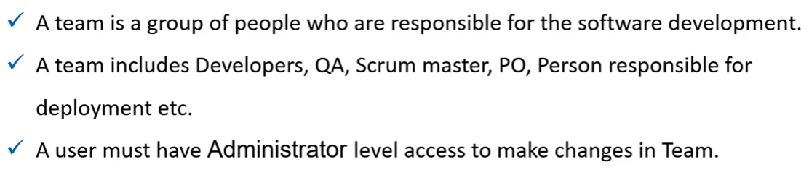

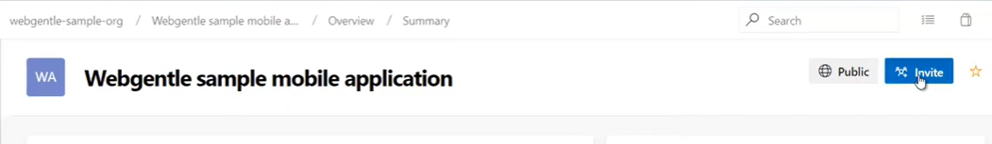

* We can select the invite option above and add the user to the existing team as below.

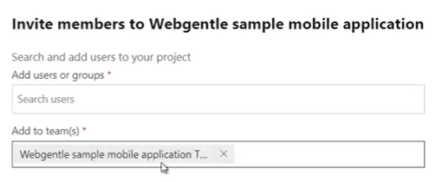

* When we simply add the user mail ID above and invite to the group. An auto generated email will be sent to that email ID as below.

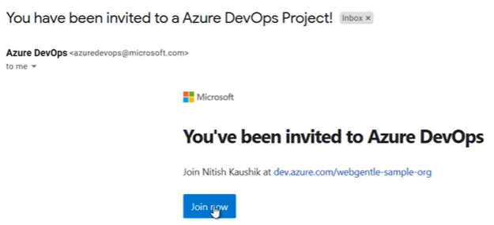

* We can also resend the invite again by going to **organisation settings🡪users🡪select the user🡪resend invite as below.**

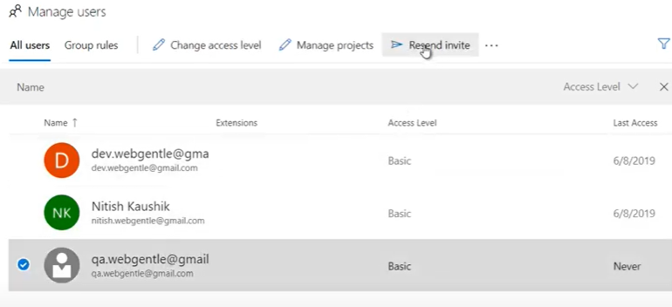

* We can also go to **project settings** 🡪 **teams and add user as below.**

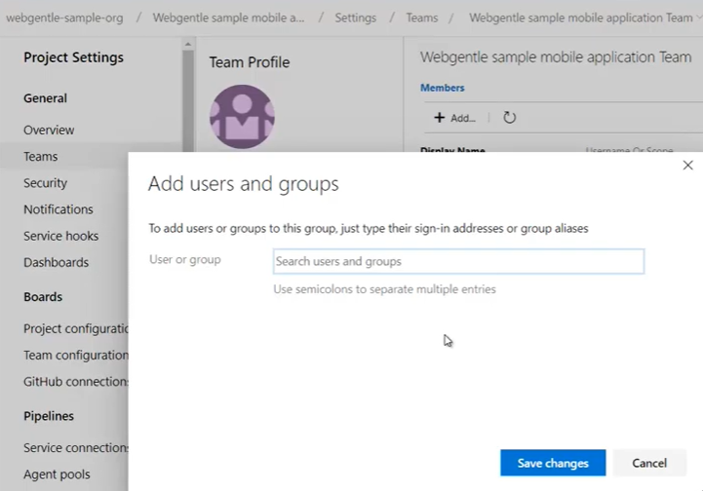

* We can add multiple users by separating with semicolon **(;)**

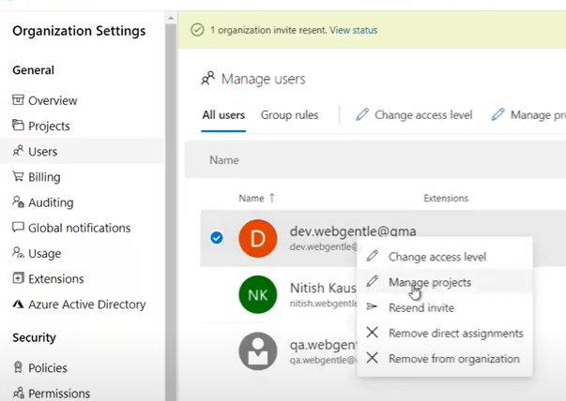

* We can go to **organisation settings**🡪**users**🡪**right click on the user and change the access level** for that user as above.
* Also, we can choose “manage projects” option to add or remove user from a project or change the group as below.

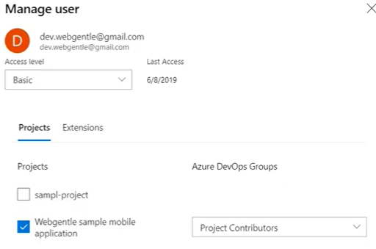

**Repositories:**

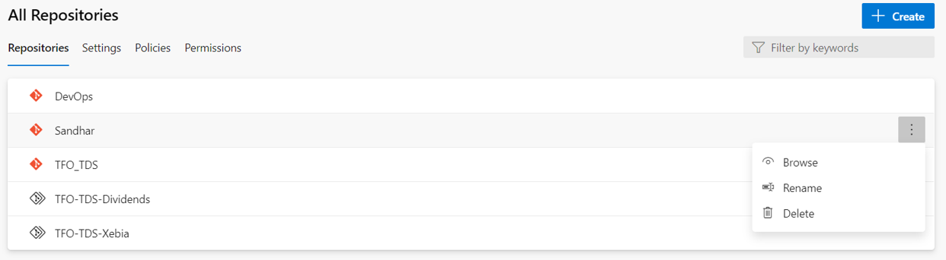

* Here, we can view repo details or create new repository. We can **rename or delete** the repo from here.
* We can also go to repo drop down in repos section in main page and create the repository from there and we can also go to repository settings from there.
* If we click on the branch, we can see the settings as below.

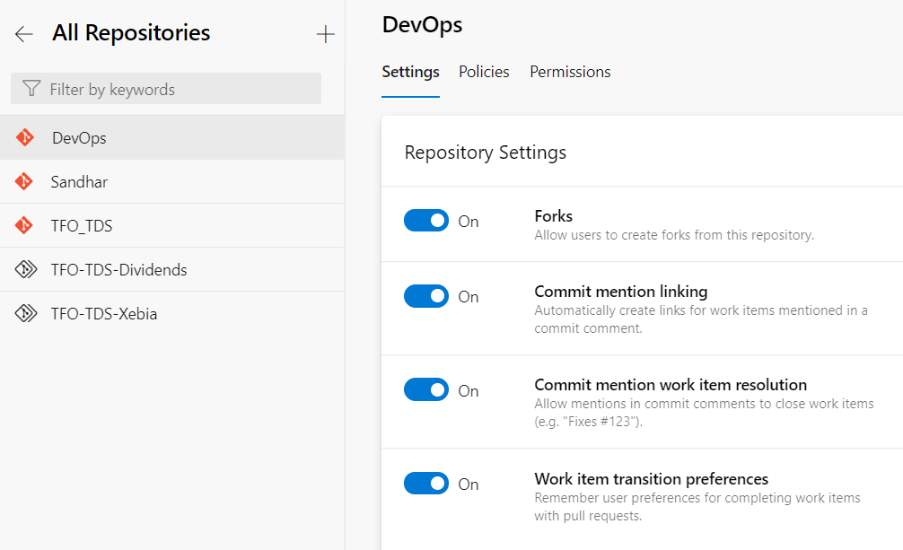

* Also, we can enable below policies on the repository level.

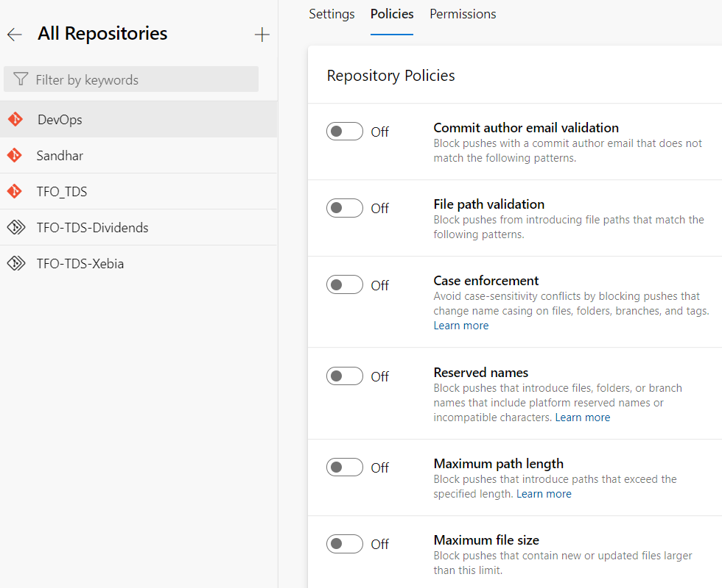

* Using above options, we can set also set the limitation in repository where it can reject push if the path length of file size is high
* And we can give the below permissions to users or groups on repository level.

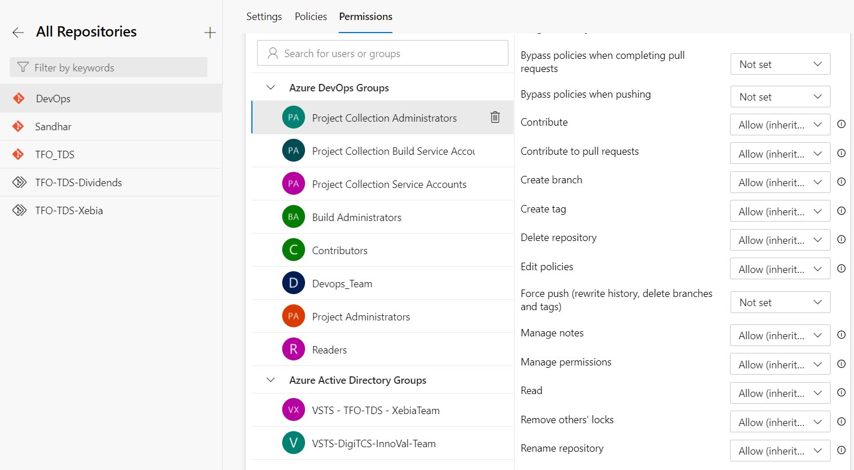

* Here, we can enable/disable the permissions in repository level like create branch/tag, delete repo, bypass policies, remove other’s locks, edit policies, force push to delete branch/tag, manage permissions etc.